0000.docProblems

Revision History
Date | Version | Description | Author
03/19/2009 | 0.1 | Initial Draft. | Huong Luu
03/23/2009 | 0.2 | Move Summary section to new tab | Huong Luu
04/26/2009 | 0.3 | Updated throughout | Suong Tran
06/01/2009 | 0.4 | Reviewed by Dev and QC Team.  Create some comments to clarify with PM | Suong Tran
06/02/2009 | 0.5 | Added alternative flow 7, exception flow 5.2 | Suong Tran

Table of Contents
1 Use Case Description 5
1.1 Brief Description 5
1.2 Actors and UC Associations 5
2 Pre-conditions 5
3 Post-conditions 5
4 Flow of Events 6
4.1 Basic Flow – View Problems 6
4.2 Alternative Flow 1 – Create a new problem 6
4.2.1 Main Flow 6
4.2.2 GUIs 6
4.3 Alternative Flow 2 – Update problem 12
4.3.1 Main flow 12
4.4 Alternative Flow 5 – Delete problem 12
4.5 Alternative Flow 4 – Escalate Problem 12
4.5.1 Main flow 12
4.5.2 GUI 13
4.6 Alternative Flow 5 – Edit Escalated Problem 14
4.6.1 Main flow 14
4.7 Alternative Flow 6 – Causal Analysis Problem 14
4.7.1 Main flow 14
4.7.2 GUI - View Problem Causal Analysis 15
4.8 Alternative Flow 7 – Create problem from risk 15
4.8.1 Main flow 15
4.9 Alternative Flow 8 – De-escalate problem 15
5 Exception Flow 16
5.1 Exception Flow 1 - CAAR of the problem does not exist 16
5.2 Exception Flow 2 – Could not delete problem 16
6 Business Rules 16
7 Special Requirements 16

UC200 Manage Project Problems

Use Case Description

Brief Description
This use case allows user to manage the problems occurred in project.
The following flows are described in this document:
- Create new problem
- Update problem
- Escalate problem
- Update escalated problem
- Casual Analysis problem
- Create new problem from an occurred risk

Actors and UC Associations
Actors:
- PM, Project members who are assigned to manage problems.
- Other users just view the page only.
Use Case Associations:
UC005 – Create Risk
UC150 – Manage Project CAAR

Pre-conditions
- The user must log in iPPDM system
- The user has access right to Problems page.

Post-conditions
The list of project problems is viewed or updated.

Flow of Events

Basic Flow – View Problems
The flow starts:
- The actor is in a project page and chooses menu “Problems”.
- The system displays a page as described in GUI – Problem Management, with three tabs:
- Tab “Summary” displays a summary how many problems and how many escalated problems by status
- Tab “Problems” displays problems list for project.
- Tab “Escalated Problems” displays a list of problems which are escalated to upper level for PM view
  - For Project Member, the system allows the user to view all problems which are related to an "escalate to" person.
- Problem Description as hyper-text to view detail of problem
The flow ends.

Alternative Flow 1 – Create a new problem

Main Flow
- In tab “Problems”, the actor chooses “Add” button.
- The system displays a new page as described in GUI – Add new problem.
- The actor enters data and chooses “Save” button.
- The system saves data and returns to “Problem” list page.
The flow ends.
Note: The actor can also select checkboxes and choose “Delete” to remove the selected problems.

GUIs
- Screens Flow
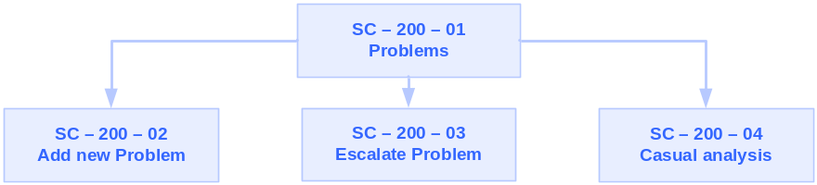
- GUI – View Summary /Problems/Escalate Problems

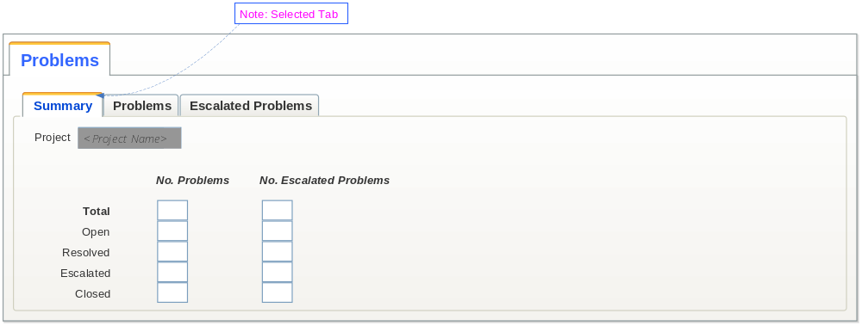
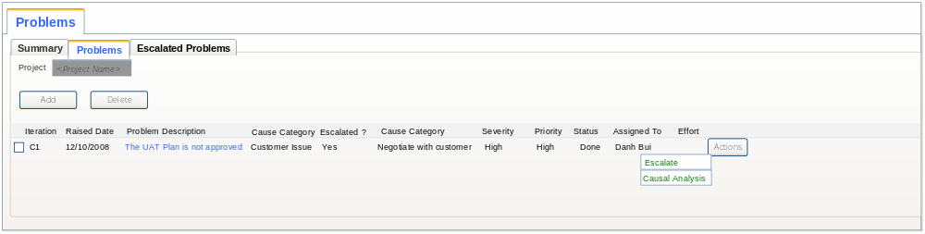

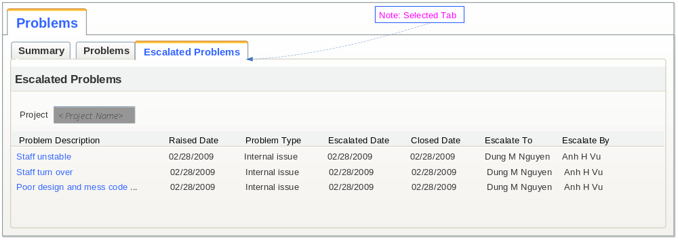

Elements of GUI – Problems(3 tabs)

Name | Type | Description | Action | Results | Field size | Required | Default | Rules
Tab Summary
Project Name | Text | The project user logged in | Read only |  |  |  |  | Display automatically
Total | Numeric | Total number of problems and total number of escalated problems | Read only |  |  |  |  | Generate automatically base on the problem list
Open, Resolved, Escalated, Closed |  | Number of problems by each status  Number of escalated problems by each status | Read only |  |  |  |  | Generate automatically base on the problem list
Tab Problems
Iteration | Text |  | Read only
Raised date | Time/Date |  | Read only
Problem description | Hyperlink |  | Click | Display detail form
Problem type | Text |  | Read only
Escalated? | Checkbox |  | Read only
Action | Text |  | Read only
Severity | Text |  | Read only
Priority | Text |  | Read only
Status | Text |  | Read only
Assigned to | Text |  | Read only
Assigned to (1) | Text |  | Read only
Assigned to (2) | Text |  | Read only
Target Date | Time/Date |  | Read only
Closed Date | Time/Date |  | Read only
Effort  (person-hrs) | Numeric |  | Read only
Add | Command  button
Delete | Command button
Actions | Popup button | Provide two options: Escalate and Causal analysis. | Select | Displays appropriate form |  |  |  | “Escalate” – Form Escalate Problem  “Causal analysis” – Form View Problem CAAR.
Tab List Escalated Problems
Project Name | Text | The project user logged in | Read only |  |  |  |  | Display automatically
Problem Description | Hyperlink |  | Click | Display detail form
Raised Date | Time/Date |  | Read only
Problem Type | Text |  | Read only
Escalated Date | Time/Date |  | Read only
Closed Date | Time/Date |  | Read only
Escalate To | Text |  | Read only
Escalate By | Text |  | Read only

GUI – Add new problem
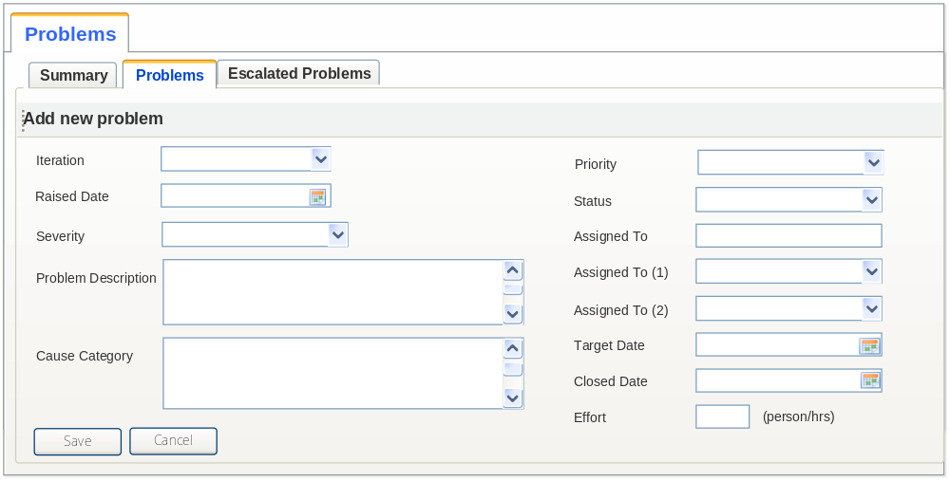
Elements of GUI - Add new problem

Name | Type | Description | Action | Results | Field size | Required | Default | Rules
Iteration | Dropdown list |  | Select |  |  | Y |  | List of the project milestones
Raised date | Time/Date |  | User input |  |  |  | Current date | Editable
Problem description | Text |  | User input |  |  | Y
Cause Category | Text Area |  | User Input |  |  | N
Severity | Dropdown list |  | Select |  |  | Y | First item | Values: Critical, High, Medium, Low
Priority | Dropdown list |  | Select |  |  | Y | First item | Values: Critical, High, Medium, Low
Status | Dropdown list |  | Select |  |  | Y | First item | Values: Open, Resolved, Escalated, Closed
Assigned to | Dropdown list |  | Select |  |  | N |  | List of available project members
Assigned to (1) | Dropdown list |  | Select |  |  | N |  | List of available project members
Assigned to (2) | Dropdown list |  | Select |  |  | N |  | List of available project members
Target Date | Date |  |  |  |  | N
Closed Date | Date |  |  |  |  | N
Effort  (person-hrs) | Numeric |  | User input |  |  | N

Alternative Flow 2 – Update problem

Main flow
- The actor chooses the hyperlink of the problem description tab List of problem. (Refer to GUI – Problems)
- The system displays an editable form as described similar to GUI-Add new problem
- The actor can modify the content of the problem and choose “Save” button.
  - When the PM update the status of problem to "Closed" the system automatically update the "Closed Date" at current date.
  - Only PM selects to change Assigned To, Assigned To (1), or Assigned To (2). Project Member who assigned to manage this problem can not changes above fields.
- The system saves data and turns back to the Problem Tab. The flow ends.

Alternative Flow 5 – Delete problem
Pre-condition:

The flow starts:
- The actor views the tab “Problem”, selects problem and chooses to Delete
- The system checks:
  - If the problem has status “Resolved” or “Closed”, the system prompt the message to confirm deletion [GN-002].
  - Otherwise, refer to Exception Flow 2 – Could not delete problem
- The actor acknowledges the message
- The system deletes and display message [GN-014]
The flow ends.

Alternative Flow 4 – Escalate Problem

Main flow
- The actor is in tab “Problems”, clicks on “Actions” button of a problem and selects “Escalate” option.
- The system will display a form as described in GUI – Escalated Problem.
- The actor inputs data and chooses “Save” button.
- The system changes the status of “Escalated” checkbox (of the problem) to “Selected”, saves the problem to Escalated Problem list and turns back to tab “Problems”.
- The system also automatically sends email to the “Escalate to” person. The use case ends.
Note: Template of the email:
Subject: Escalated problem from project [project name]
Body: [Login user] from project [project name] has escalated to you a problem as described below.
Problem: [Problem description]
Raised Date: [Raised Date]
Problem Type: [Problem Type]
Escalated Date: [Escalated Date]
Closed Date : [Close Date]

GUI
- GUI – Escalated Problem
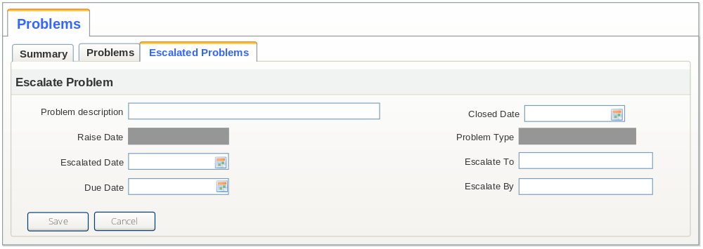
- GUI elements

Name | Type | Description | Action | Results | Field size | Required | Default | Rules
Problem ID |  |  |  |  |  |  |  | System automatically generates
Problem description | Text |  | Read only |  |  |  |  | Default the same with the “Problem description”.
Raised Date | Date |  | Read only |  |  |  |  | Default the same with the problem’s “Raised date”.
Problem Type | Text |  | Read only |  |  |  |  | Default the same with the problem’s “Problem Type”.
Escalated Date | Date |  | Read-only |  |  |  | Current Date
Due Date | Date |  | User input |  |  |  | Due Date > Escalate Date
Closed Date | Date |  |  |  |  |  | Closed Date > Escalate Date
Escalate To | Dropdown list |  | User input |  |  |  |  | List of available users
Escalate By | Text |  | Read-only |  |  |  | Login user

Alternative Flow 5 – Edit Escalated Problem

Main flow
- The actor is in tab “Escalated Problems”, clicks on the hyperlink of the problem.
- The system will display a form as described in GUI –Escalated Problem.
- The actor modifies data and chooses “Save” button
- The system saves modification and turns to tab “Escalated Problems”.
- The system also automatically sends email to the “Escalate To” person if this field changes . The flow ends.
Note: Template of the email:
Subject: Escalated Problem from project [project name] is updated
Body: [Login user] from project [project name] has escalated to you a problem as described below.
Problem: [Problem description]
Raised Date: [Raised Date]
Problem Type: [Problem Type]
Escalated Date: [Escalated Date]
Closed Date : [Close Date]

Alternative Flow 6 – Causal Analysis Problem

Main flow
- The actor is in tab “Problems”, clicks on “Actions” button of a problem and selects “Causal Analysis” option.
- The system proceeds as follows:
- If the problem has existing CAAR, the system show CAAR screen as described in GUI – View Problem Causal Analysis. Go to step 3.
- Otherwise, the system displays an error message, refer to Exception Flow 1 - CAAR of the problem does not exist. The flow ends here.
- The actor chooses “Cancel” button.
- The system closes the form and turns back to “Problems”. The flow ends

GUI - View Problem Causal Analysis
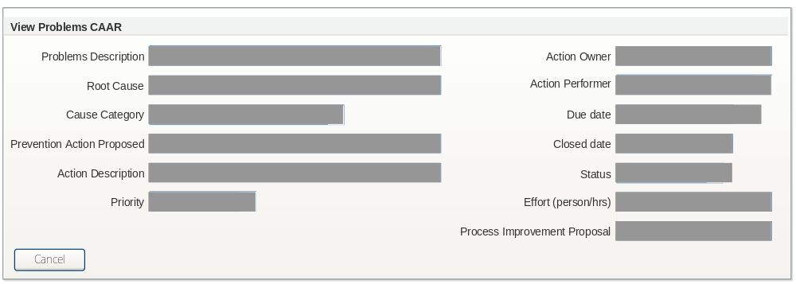

Alternative Flow 7 – Create problem from risk

Main flow
- The actor is in Risk list page (UC 005 Create Risk, section 7.1), views the detail of a risk, changes status of the “Occurred?” checkbox to “Selected” and chooses “Save” button.
- The system displays a message [MP-003] and provides two options: “Yes” “No”.
- The actor chooses “Yes”
- The system displays screen similar to Add New Problem screen that automatically indicated the field “Problem description” by the content of field “Risk Description” (editable) and the field “Action” by the content of “Contingency Plan”
- The actor enters more information and chooses “Save” button.
- The system saves item to project problem list and turns back to Risk list page. The flow ends.

Alternative Flow 8 – De-escalate problem
The flow starts:
- The actor is “Escalate problem” list and chooses to de-escalate problem.
- The system displays a message [MP-004] and provides two options: “Yes” “No”.
- The actor chooses “Yes”
- The system updates problem to un-check escalate and re-send email:
Note: Template of the email:
Subject: De-escalated Problem from project [project name]
Body: [Login user] from project [project name] has de-escalated to you a problem as described below.
Problem: [Problem description]
Raised Date: [Raised Date]
Problem Type: [Problem Type]
Escalated Date: [Escalated Date]
Closed Date : [Close Date]
Then, ‘Escalate To’ person has no permission to manage this problem anymore
The flow ends

Exception Flow

Exception Flow 1 - CAAR of the problem does not exist
- At step 2.a of Alternative flow 5, if the CAAR of the selected problems does not exist.
- The system displays a message [MP-005].
- The actor acknowledges message
- The system closes the message.

Exception Flow 2 – Could not delete problem
When the user chooses to delete problem has been escalated or opened, the system displays error message [MP-006]

Business Rules
Escalate Criteria: the problem shall be escalated when it can not be resolvable at the project level or the target date us in due but not much or no progress of solving problem is made.

Special Requirements

